***Project details & 5-week plan***

**CSE 299 section 5**

**Project name:** *The Amazing App*

**Group Members:**

1. *Ridwan Shikder 1912089642*
2. *Faiaz Khan 1912414642*
3. *Tariq Nazmus Sadat 1711328042*
4. *Asadujjaman 1821301642*

***Project:*** *The Amazing App*

***Platform:*** Web

***product overview:*** A software which encrypts and decrypts files on a google drive and authenticates the user via face recognition.

***Requirements:***

1. *Login:*

• Google authorized login

Priority: Low

2. *Face verification:*

• verifies user

• takes an initial picture and uses it

• Will verify face every time phone screen is turned off

• Anti-spoofing Accuracy High

Priority: High

3. *Encryption:*

• Added files through the app will be encrypted and then saved on the drive

• Files will be .DOC and .PDF

Priority: Medium

4. *Decryption:*

• When selecting a file from the drive through the app, the file will be decrypted

• A temp decrypted file will be made

• Temp file will be deleted when the tab is closed/user logs out/user face mismatch or absent

• Temp file will be deleted when the app is closed

Priority: Medium

***UML Use Case:***

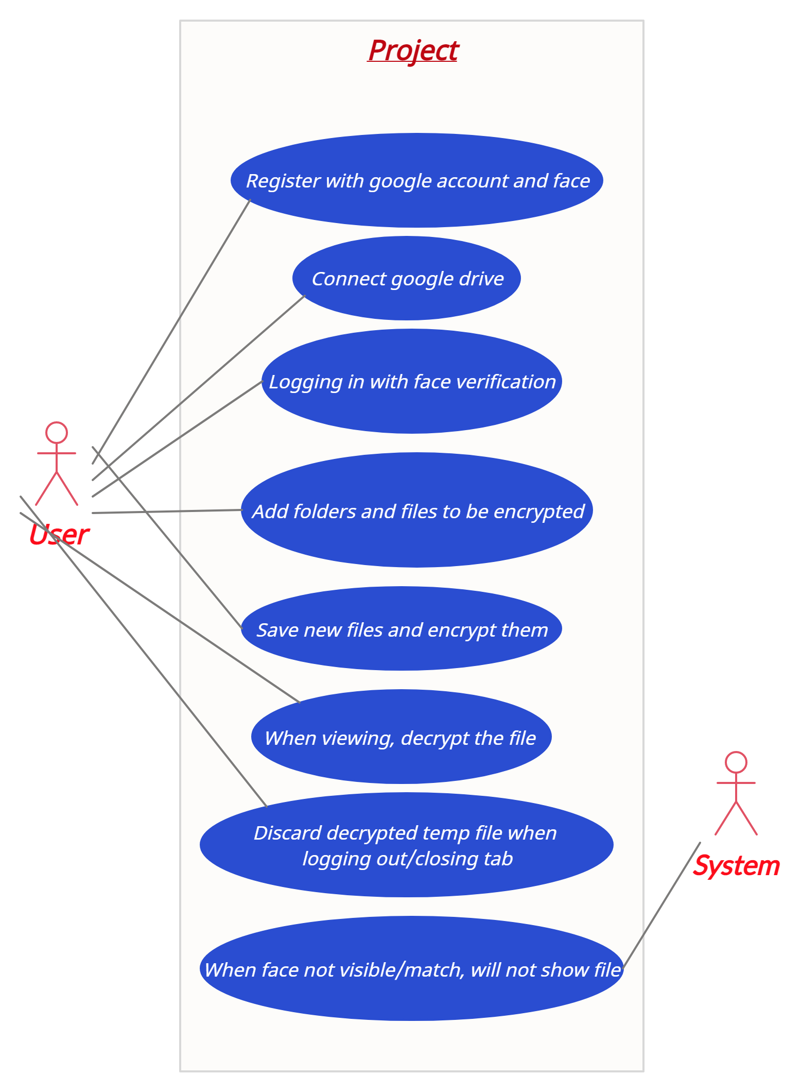

***5 Week plan:***

*Week 1:* Building the registration and logging in features (does not include face authentication) using Oauth 2.0 for google sign in and also connecting the google drive of the user. A barebone webpage to sign in and register, further designs will be done in week 5.

*Week 2:* Constructing and implementing the file encryption and decryption systems. This also includes saving files to the drive via the web app. Barebone UI, better UI will be designed on week 5.

*Week 3:* Applying face recognition to logging in feature. We will also add constant face monitoring while the tab is open or the user is logged in.

*Week 4:* Enhancing the face recognition with anti-spoofing algorithms to further increase security for the user.

*Week 5:* The web app will be fully designed into a responsive web site with the end goal being a user-friendly UI. Also includes testing and minor bug fixing if any.